Bash scripting task -2
Git repository link: https://github.com/rojalatha49-bit/Bash-scripts
- Launch an Amazon Linux Ec2 instance
- Connect to ec2 instance with SSH
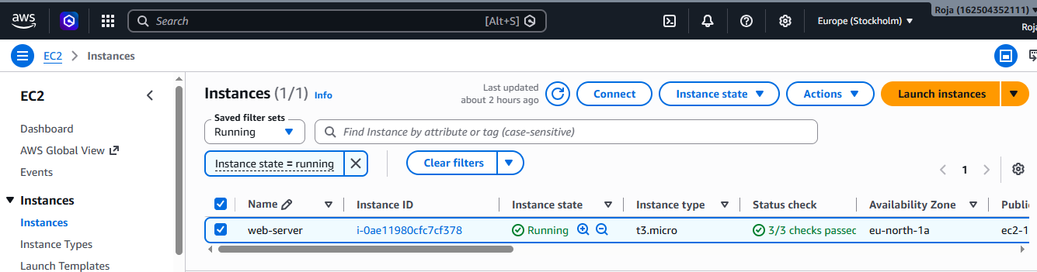

1. Create a bash script to check if a directory is available or not.

- Switch to root user using sudo su and create a directory with name ‘phase’ using mkdir phase.
- View the directory using ls, now we can see directory with name phase is in the list.
- Create and insert script using vi phase.bash. Then save file using Esc:wq!
- Give execute permission using chmod 755 phase.bash and read the script using cat phase.bash.
- Now run the script using ./phase.bash. We can see output as directory exists.

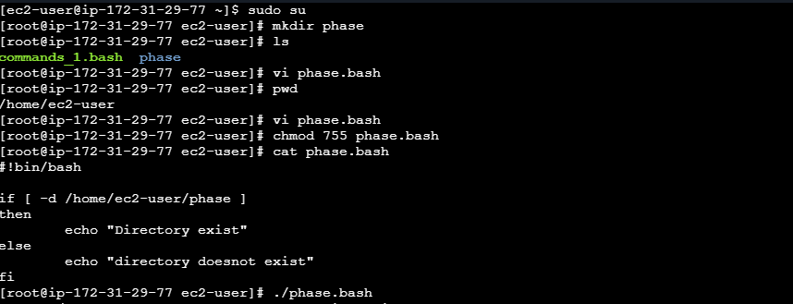

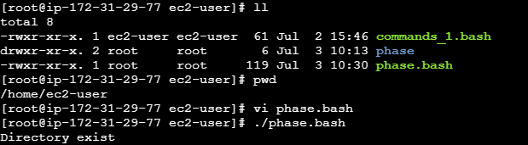

2. Create a bash script to create multiple files.
- Create and insert script using vi multiplefiles.bash. Then save file using Esc:wq!
- Give execute permission using chmod 755 multiplefiles.bash.
- When we run the script using ./multiplefiles.bash, we see that output displays 5 files created successfully.
- Now to verify use command ll and see that 5 files are listed.

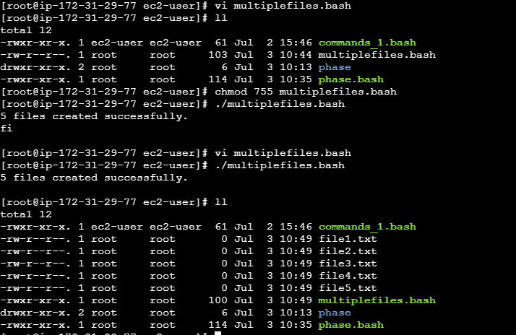

3. Create a bash script to take a backup of a directory.

- Create and insert script using vi backupd.bash. Then save file using Esc:wq!
- Give execute permission using chmod 755 backupd.bash.
- When we run the script using ./backupd.bash, we see that output displays backup created successfully.
- Now to verify use command ll and see that backup is created for the directory and is listed.

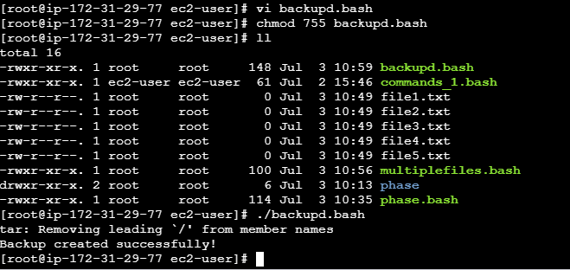

4. Create a bash script to install Nginx on an EC2 server.

- Create and insert script using vi installnginx.bash. Then save file using Esc:wq!
- Give execute permission using chmod 755 installnginx.bash.
- Run the script using ./installnginx.bash. Nginx starts installing.
- Now use systemctl status nginx and see active (running)
- Also allow HTTP (Port 80) from 0.0.0.0/0 in security group.
- Copy and paste Ip address in browser. If nginx is installed properly, we see Welcome to nginx! page

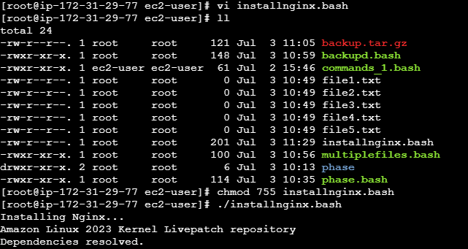

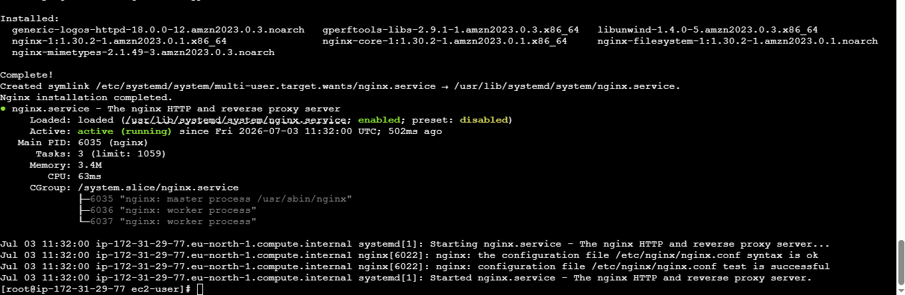

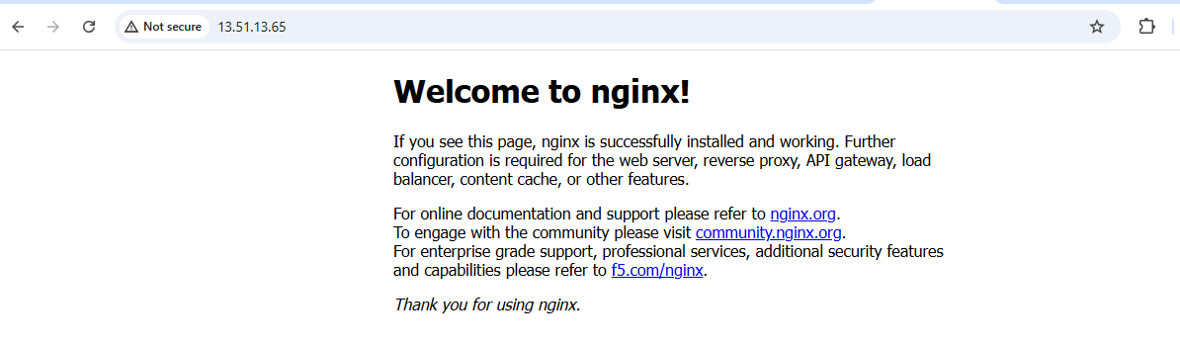

5. Create a bash script to install Apache Tomcat on an EC2 server.

- Create and insert script using vi install_tomcat.bash. Then save file using Esc:wq!
- Give execute permission using chmod 755 install_tomcat.bash.
- Run the script using ./install_tomcat.bash. Tomcat starts installing.
- Using ps -ef | grep tomcat check the status
- Also allow HTTP (Port 80) from 0.0.0.0/0 in security group.
- Copy and paste Ip address in browser. If tomcat is installed properly, we see Apache Tomcat welcome page

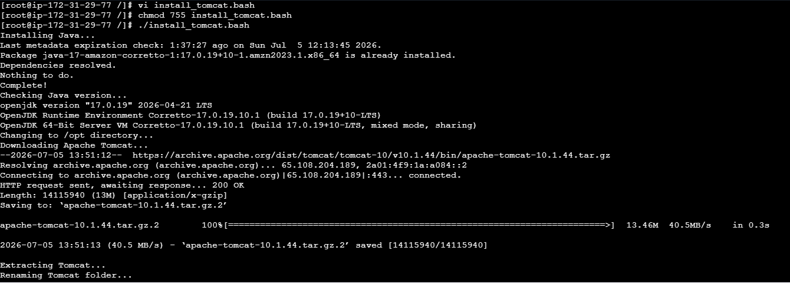

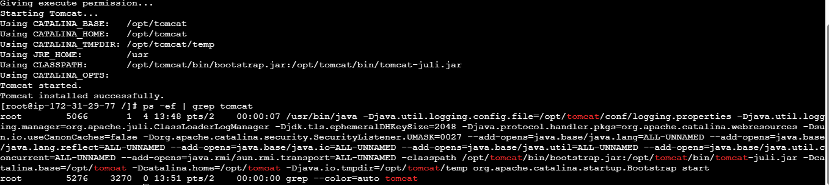
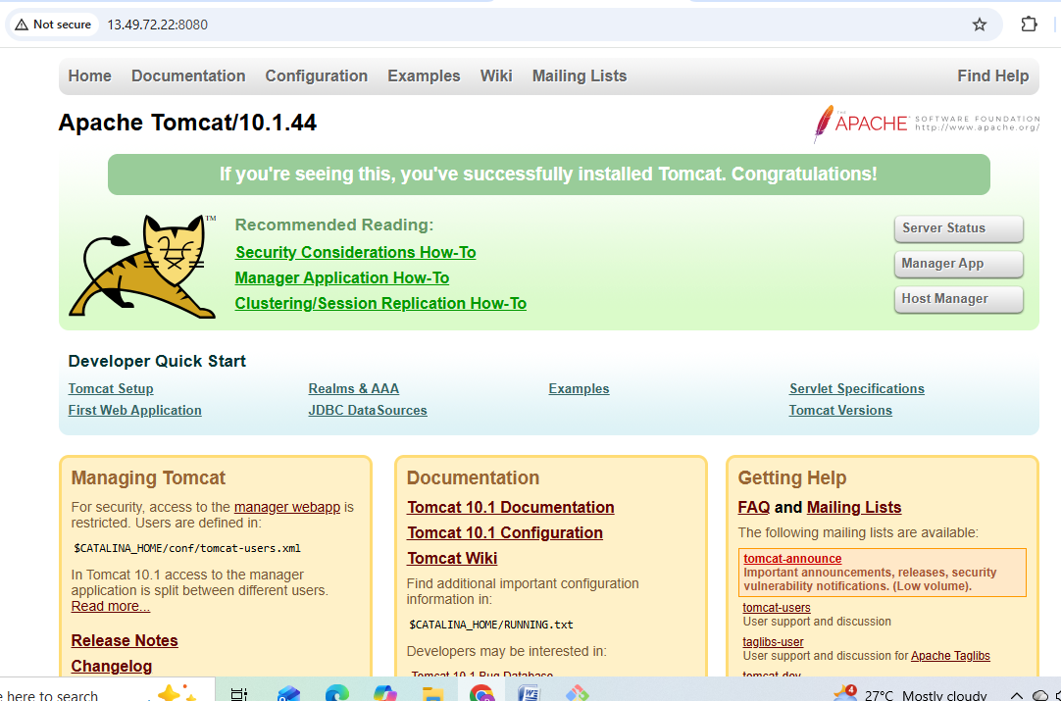

6. Create a bash script to check if the Nginx service is running, if not running then script should start the service.

- Create and insert script using vi nginx_check.bash. Then save file using Esc:wq!
- Give execute permission using chmod 755 nginx_check.bash.
- Run the script using ./nginx_check.bash. We see output as Nginx is not running and starting Nginx…

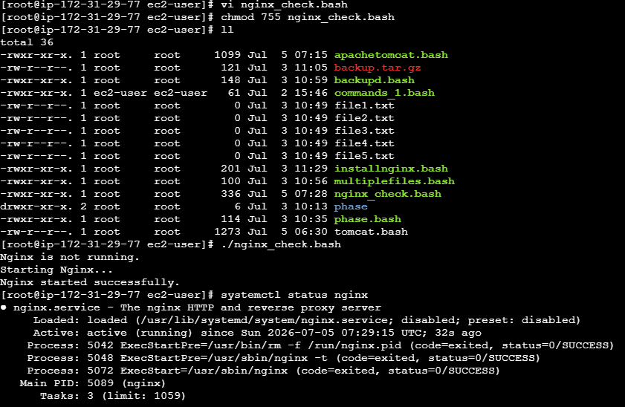

7. Create a bash script for a calculator.

- Create and insert script using vi nginx_check.bash. Then save file using Esc:wq!
- Give execute permission using chmod 755 nginx_check.bash.
- Run the script using ./nginx_check.bash.
- It says to enter first and second number. Also asks to choose an operation and finally gives the expected output.

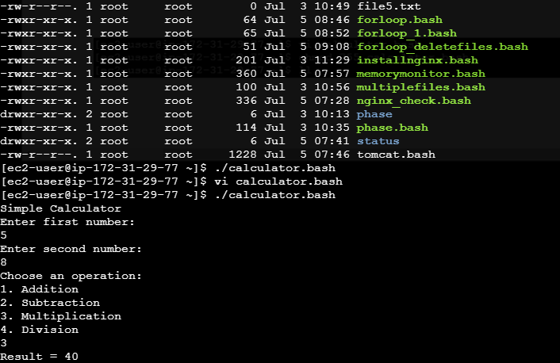

8. Create a bash script to check if a directory exists, if not then create a directory.

- Create and insert script using vi check_directory.bash. Then save file using Esc:wq!
- Give execute permission using chmod 755 check_directory.bash.
- Run the script using ./check_directory.bash.
- In the output, it asks to enter the directory name. When name is given it checks if the directory exists and if directory doesnot exist, it creates one with that name.

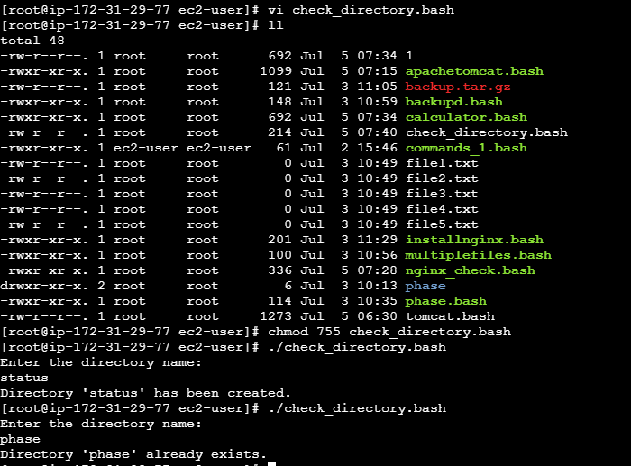

9. Create a bash script to delete the last 3 lines of a file.

- Create and insert script using vi delete_last3lines.bash. Then save file using Esc:wq!
- Give execute permission using chmod 755 delete_last3lines.bash.
- Run the script using ./delete_last3lines.bash.
- Output asks to enter the file name, after giving the file name it says file consists of 3 or fewer lines and cannot delete the last 3 lines

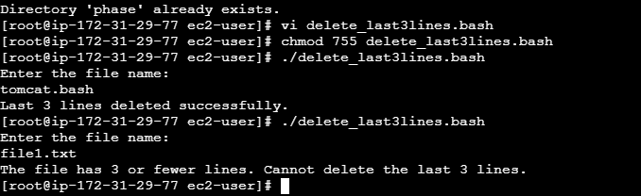

10. Bash script to monitor cpu and if it is more than 80% then send email notification.

- Create and insert script using vi cpumonitor.bash. Then save file using Esc:wq!
- Give execute permission using chmod 755 cpumonitor.bash.
- Run the script using ./cpumonitor.bash.
- As the cpu usage is below 80% we see that it says cpu usage is normal :0% else if usage is above 80% it sends email notification.

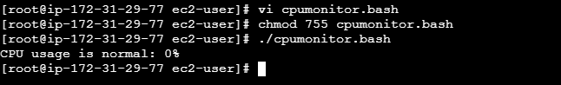

11. Bash script to monitor disk space and if it is more than 80% then send email notification.

- Create and insert script using vi diskspace.bash. Then save file using Esc:wq!
- Give execute permission using chmod 755 diskspace.bash.
- Run the script using ./diskspace.bash.
- As the disk space usage is below 80% we see that it says usage is normal: 25% else if usage is above 80% it sends email notification.

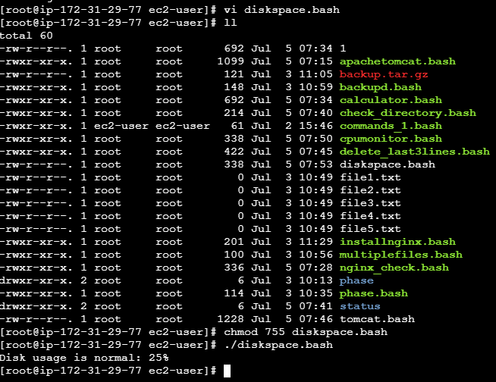

12. Bash script to monitor memory and if it is more than 80% then send email notification.

- Create and insert script using vi memorymonitor.bash. Then save file using Esc:wq!
- Give execute permission using chmod 755 memorymonitor.bash.
- Run the script using ./memorymonitor.bash.
- As the memory usage is below 80% we see that it says memory usage is normal: 22% else if usage is above 80% it sends email notification.

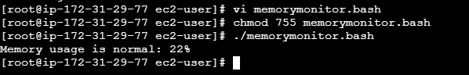

Crontab Entries

- April 5th Midnight

- Install crontab using sudo yum install cronie -y
- Create and insert script using vi addcron.bash. Then save file using Esc:wq!
- Give execute permission using chmod 755 addcron.bash.
- Run the script using ./addcron.bash.
- Verify using crontab –l and we see output as 0 0 5 4 * /home/ec2-user/script.sh

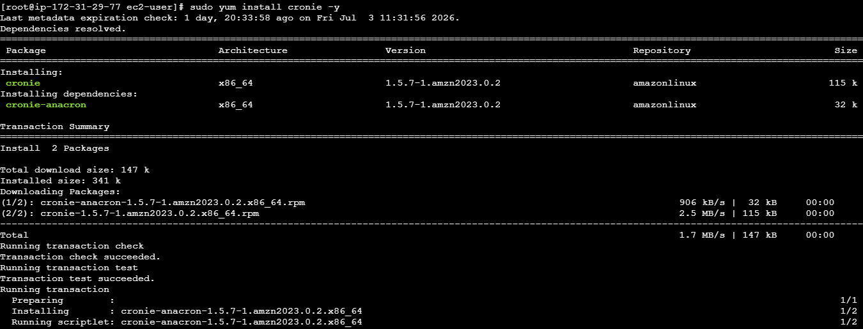

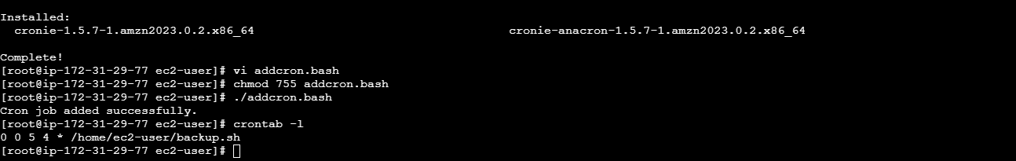

2. 5th of Every November, January, June if it is a Thursday

- Create and insert script using vi addcron_1.bash. Then save file using Esc:wq!
- Give execute permission using chmod 755 addcron_1.bash.
- Run the script using ./addcron_1.bash.
- Verify using crontab –l and we see output as 0 0 5 1,6,11 * [ "$(date +\%u)" -eq 4 ] && /home/ec2-user/script.sh

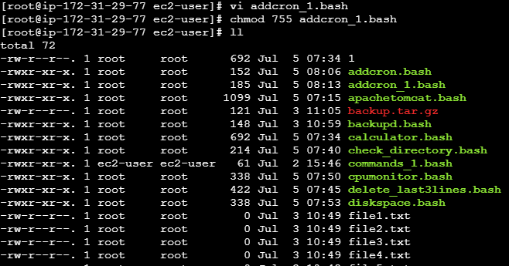

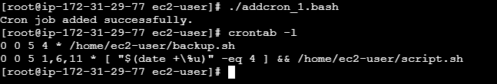

3. At 05 and 27th minutes of 9, 10, 11 hours every day

- Create and insert script using vi addcron_2.bash. Then save file using Esc:wq!
- Give execute permission using chmod 755 addcron_2.bash.
- Run the script using ./addcron_2.bash.
- Verify using crontab –l and we see output as 5,27 9-11 * * * /home/ec2-user/script.sh

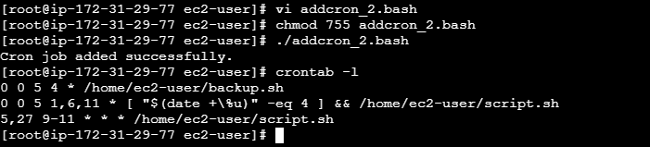

4. 34 minutes of 9th hour on15th August

- Create and insert script using vi addcron_3.bash. Then save file using Esc:wq!
- Give execute permission using chmod 755 addcron_3.bash.
- Run the script using ./addcron_3.bash.
- Verify using crontab –l and we see output as 34 9 15 8 * /home/ec2-user/script.sh

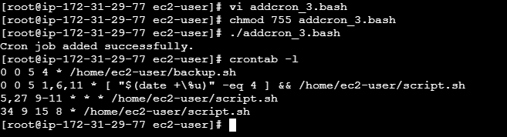

5. Every midnight

- Create and insert script using vi addcron_4.bash. Then save file using Esc:wq!
- Give execute permission using chmod 755 addcron_4.bash.
- Run the script using ./addcron_4.bash.
- Verify using crontab –l and we see output as 34 9 15 8 * /home/ec2-user/script.sh

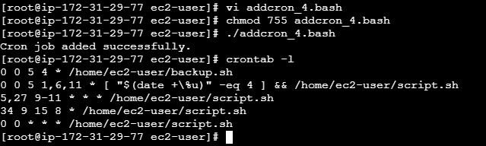

6. Every Weekend (Saturday night 11:59 PM)

- Create and insert script using vi addcron_5.bash. Then save file using Esc:wq!
- Give execute permission using chmod 755 addcron_5.bash.
- Run the script using ./addcron_5.bash.
- Verify using crontab –l and we see output as 59 23 * * 6 /home/ec2-user/script.sh

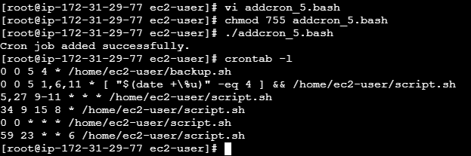

7. After every reboot

- Create and insert script using vi addcron_6.bash. Then save file using Esc:wq!
- Give execute permission using chmod 755 addcron_6.bash.
- Run the script using ./addcron_6.bash.
- Verify using crontab –l and we see output as 59 23 * * 6 /home/ec2-user/script.sh

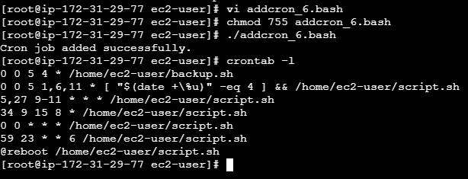

for loop Scripts:

1. Simple for loop output

#!/bin/bash
for i in 1 2 3 4 5
do
echo "Welcome $i times"
done

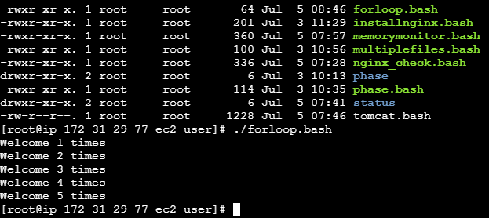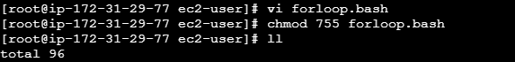

2. Simple for loop output

#!/bin/bash
for i in eat run jump play
do
echo See Imran $i
done

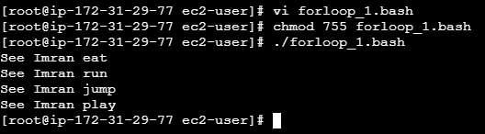

3. for loop to delete 5 files named 1-5

#!/bin/bash
for i in {1..5}
do
rm $i
done

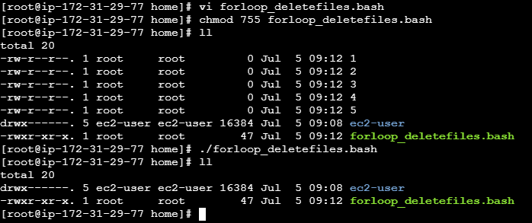

4. Specify days in for loop

#!/bin/bash
i=1
for day in Mon Tue Wed Thu Fri
do
echo "Weekday $((i++)) : $day"
done

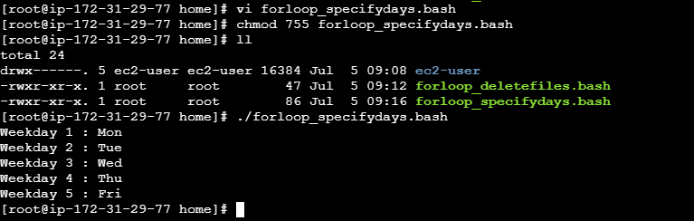

5. List all users one by one from /etc/passwd file

#!/bin/bash
i=1
for username in `awk -F: '{print $1}' /etc/passwd`
do
echo "Username $((i++)) : $username"
done

Exit status:

Return Successful Exist Status

1. ls -l
echo $?
pwd
echo $?
pwdd
echo ?

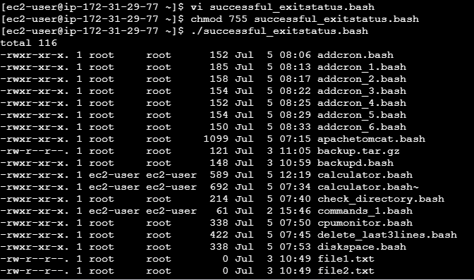

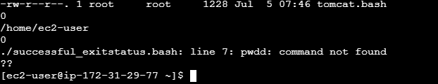

2. #!/bin/bash
echo hello
echo $?

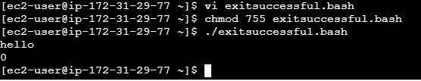

Return Un-Successful Exist Status
1.
#!/bin/bash
echi hello
echo $?

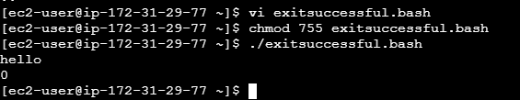

2.
#!/bin/bash
ls -l /home/iafzal/check
if [ $? -eq 0 ]
then
echo File exist
else
echo File does not exist
fi

